PARKWOOD DRIVE STORM DRAIN REPAIRED

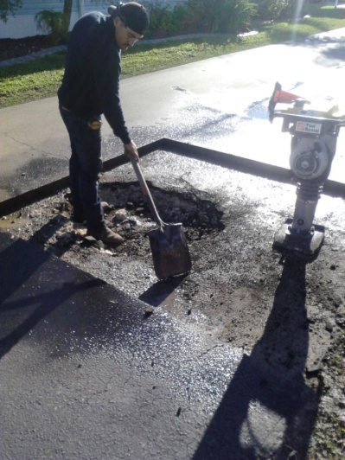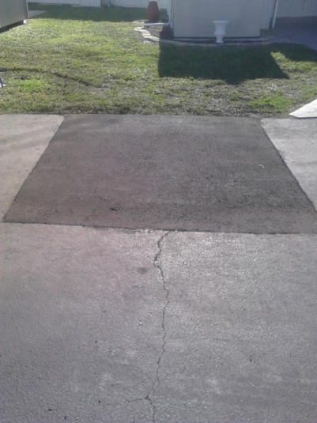

On Wednesday, February 11, 2015 SPT installed a new 21” diameter CIPP (cast in place plastic) liner in the existing failed 21” RCP (reinforced concrete pipe) between the catch basins at the intersections of N. Mobile Estates Drive and S. Mobile Estates Drive on Parkwood Drive. The project was a success other than the existing catch basin rim at intersection of S. Mobile Estates Drive was fractured while removing for access. SPT has place a plate and cones while a new catch basin rim has been ordered (no additional cost to MEHOA).
On Friday, February 13, 2015 SPT removed the steel plate on Parkwood Drive over a failed joint in the existing 21” RCP. The existing fractured asphalt pavement was removed. The affected area was neatly saw cut, new gravel was installed, and 2” of new asphalt pavement was installed compacted. Once the new catch basin rim is received a placed on the catch basin at the intersection S. Mobile Estates Drive we will be cone less and plate less on Parkwood Drive!
The Sewer & Water Committee thanks you all for making travel adjustments in your daily excursions during the project.

